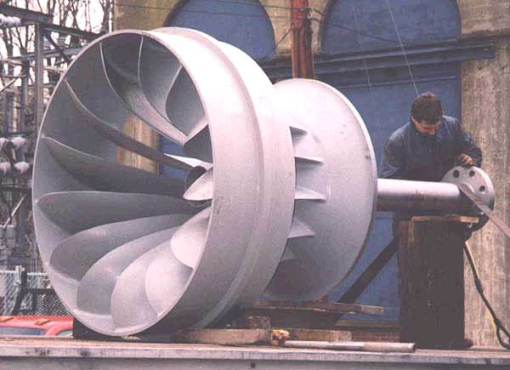
Hydroelectric dam turbine before it starts killing fish in its blades.

